**Exercise 3**

Write a HTML program for the demonstration of Lists.

1. Unordered List
2. Ordered List
3. Definition List
4. Nested List

**Solution:**

1. **Unordered List:**

<html>

<head>

<title> Exercise 3</title>

</head>

<body bgcolor= pink>

<h1 align=center> Course offered by Directorate of Online Education </h1>

<h1 align=center>Manipal University Jaipur</h1>

<ul type=square>

<li>MBA</li>

<li>BBA</li>

<li>MCA</li>

<li>BCA</li>

<li>MCOM</li>

<li>BCOM</li>

<li>MJMC</li>

</ul>

</body>

</html>

**Output:-**

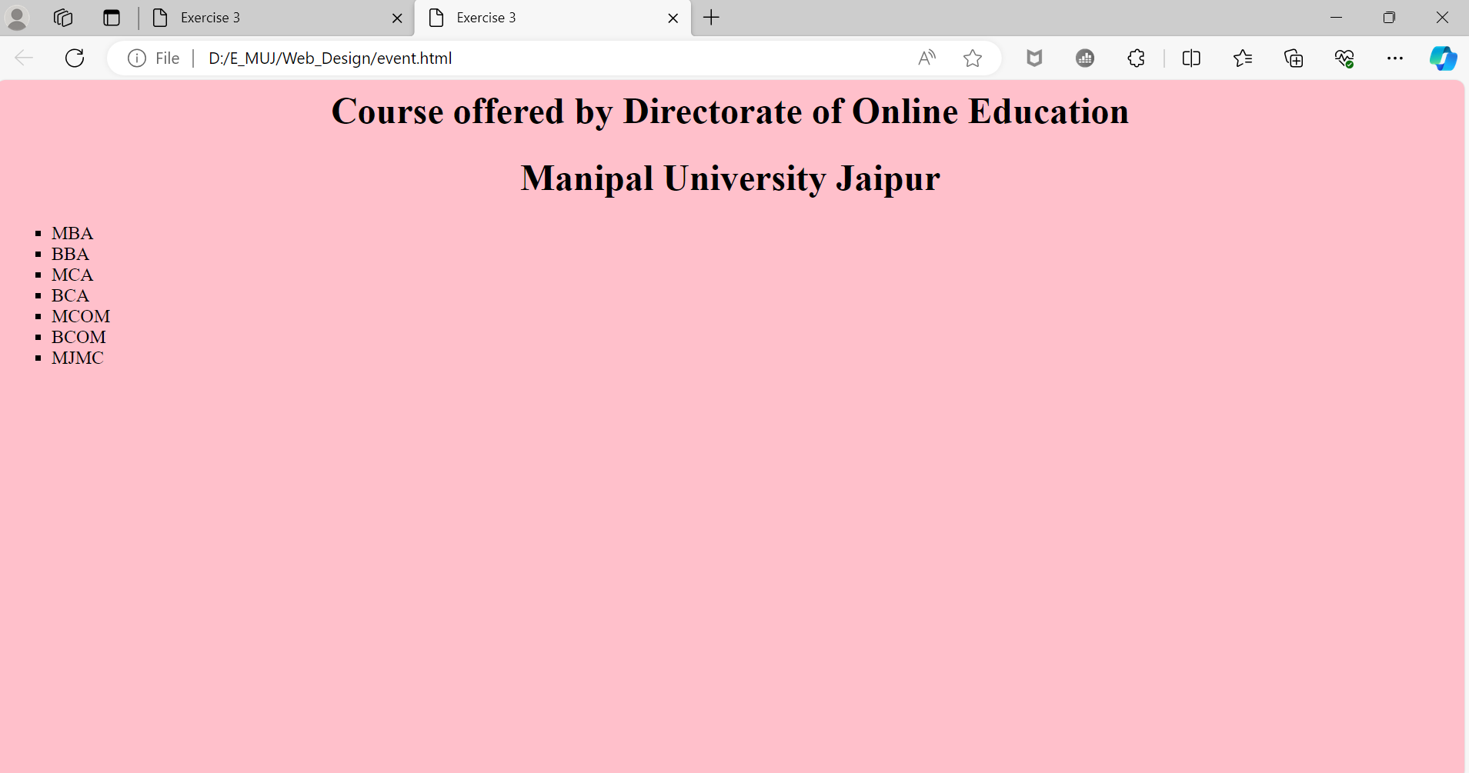

1. **Ordered List:**

**Solution:-**

<html>

<head>

<title> Exercise 3</title>

</head>

<body bgcolor= pink>

<h1 align=center> Course offered by Directorate of Online Education </h1>

<h1 align=center>Manipal University Jaipur</h1>

<ol type=A>

<li>MBA</li>

<li>BBA</li>

<li>MCA</li>

<li>BCA</li>

<li>MCOM</li>

<li>BCOM</li>

<li>MJMC</li>

</ol>

</body>

</html>

**Output:-**

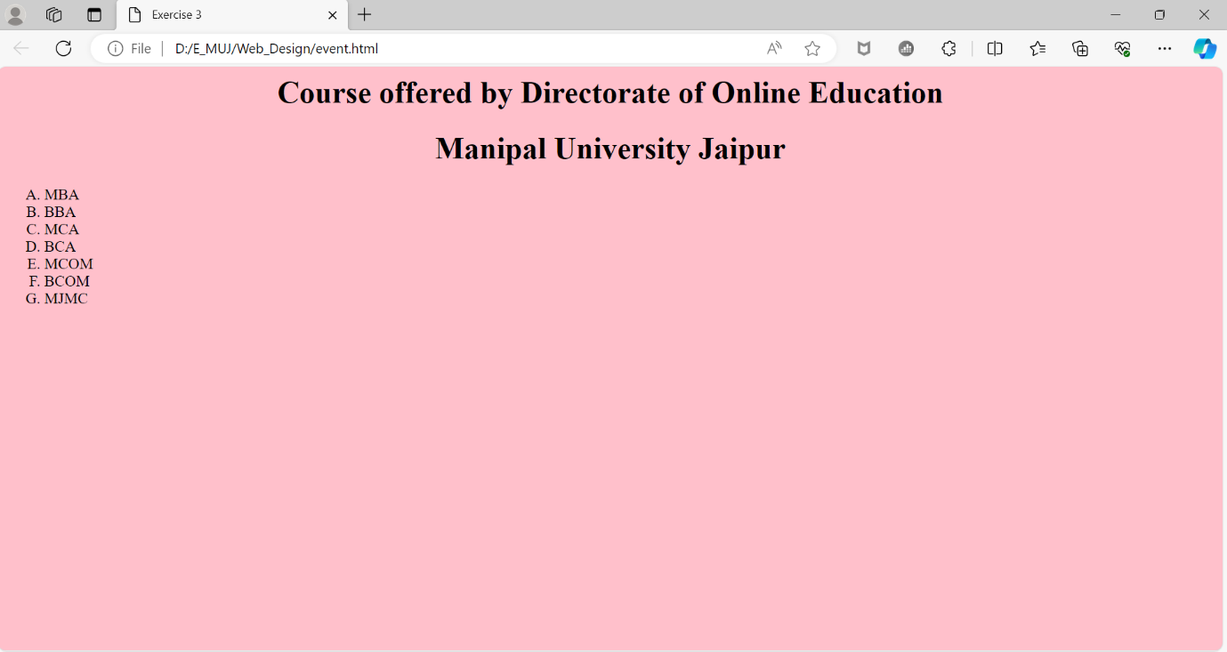

1. **Definition List:**

**Solution:-**

<html>

<head>

<title> Exercise 3</title>

</head>

<body bgcolor= pink>

<h1 align=center> Course offered by Directorate of Online Education </h1>

<h1 align=center>Manipal University Jaipur</h1>

<h1 align=center>Definition List</h1>

<dl>

<dt>MBA<dd> Master of Business Administration

<dt>BBA<dd> Bachelor of Business Administration

<dt>MCA<dd> Master of Computer Application

<dt>BCA<dd> Bachelor of Computer Application

<dt>MCOM<dd>Master of Commerce

<dt>BCOM<dd> Bachelor of Commerce

<dt>MJMC<dd>Master of Journalism & Mass Communication

</dl>

</body>

</html>

**Output:-**

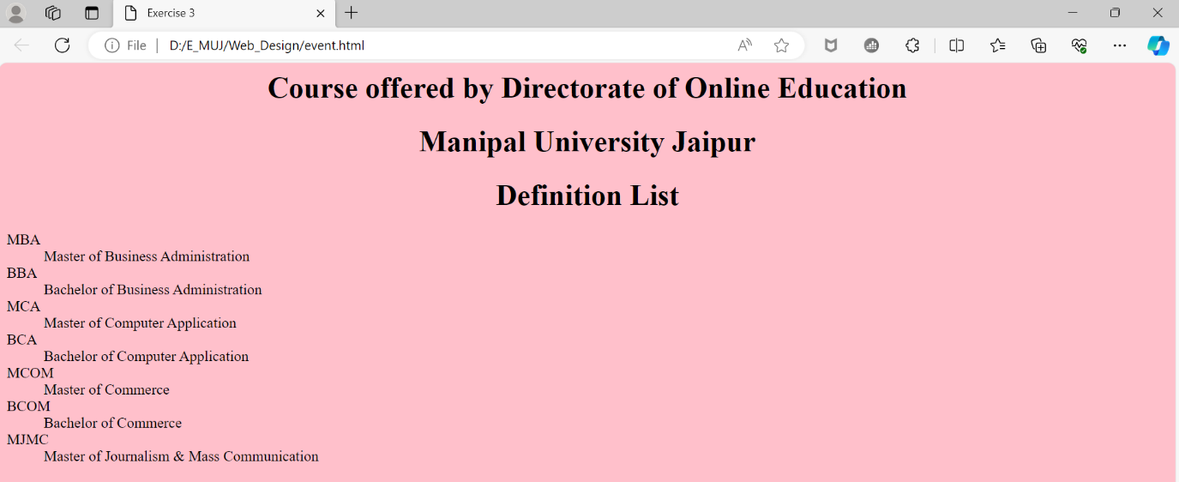

1. **Nested List:**

**Solution:-**

<html>

<head>

<title> Exercise 3</title>

</head>

<body bgcolor= pink>

<h1 align=center> Course offered by Directorate of Online Education </h1>

<h1 align=center>Manipal University Jaipur</h1>

<h1 align=center>Definition List</h1>

<dl>

<ol>

<li>Computer Application</li>

<ul>

<li>MCA</li>

<li>BCA</li>

</ul>

<li>Bisnuess Adminstration</li>

<ul>

<li>MBA</li>

<li>BBA</li>

</ul>

</ol>

</body>

</html>

**Output:-**

